Steam Fired TH750, TH500 Fluid Heater
Pre-Commissioning and Start Up Checklist

IMPORTANT NOTICES:
The check list must be completed and sent to the factory prior to factory on-site commissioning. Upon arrival to the job site to perform start-up, if the commissioning agent discovers the check list is incomplete or site conditions do not allow for the safe start-up of the unit, the commissioning will be postponed until corrective action has been performed, the initial site visit will be charged, and an additional startup cost will be incurred.
Each Thermaflo EC1000 Electronic Temperature controller has the application set point factory pre-programmed. Please do NOT attempt to change any settings before Thermaflo or factory authorized representative are on site. Attempting to change settings can damage the temperature control program and will prolong startup and VOID the controller warranty. No outside source should be wired to these panels.

Thank you for choosing Thermaflo’s steam-to-water heat exchanger for your hot water generation needs. Our equipment is made and factory pre-commissioned based on the design conditions as indicated on the approved submittal.
Each Thermaflo steam fired fluid heater must have the check list completed and returned.
To complete the pre-startup check list, you will need the following:
- Thermaflo’s as-built submittal drawing
- Copy of the TH750 and TH500 Installation & Maintenance Instructions
- Volt meter (to verify electrical voltage)
- Torque wrench
- Level
- Steam pipe sizing chart
The installing contractor or owner must complete the following check list PRIOR to scheduling factory on-site start-up & commissioning. If you have any questions on the enclosed check list, contact your local factory authorized Thermaflo representative.
If any of the responses are NO, please provide clarification with photos (where applicable) so Thermaflo can review and advise next steps so start-up can be scheduled and performed.
Send the completed pre-commissioning check list to local Thermaflo representative and send a copy to:
Thermaflo Inc.
Email: orders@theramfloengineering.com
Project Name: __________________________________________________________________
Drawing Number: ________________________________________________________________
Name of Person Completing Pre-Commissioning Checklist: _______________________________
Contact email: ___________________________________________________________________
Contact phone: ___________________________________________________________________

Check the appropriate box. | YES | NO
Is the steam supply pressure to the Thermaflo TH750 or TH500 the same as indicated on the submittal? | □ | □
Does the water-side flow rate (GPM) match the flow rate indicated on Thermaflo’s submittal? | □ | □
Is the steam piped to the location indicated on Thermaflo’s submittal? | □ | □
Is the condensate return line piped to the location indicated on Thermaflo’s submittal? | □ | □
Is the water supply piped to the location indicated on Thermaflo’s submittal? | □ | □
Is the hot water outlet piped to the location indicated on Thermaflo’s submittal? | □ | □
Is the steam pipe size large enough to provide the volume of steam needed per the indicated submittal? (Note: The Thermaflo steam control valve size is NOT the same as the steam supply line size.) | □ | □
Does the site have sufficient steam volume to provide the amount of steam lb/hr as indicated on the submittal? | □ | □
Is the condensate return pipe large enough to accommodate the volume of condensate and flash steam (Not applicable for the Thermaflo ZeroFlash and VacuFlo units) | □ | □
Is upstream isolation valve installed in the horizontal and in-line with the steam inlet to the heat exchanger? | □ | □
Is an upstream Y strainer installed and located on its side – NOT with the lower portion pointing down) and fitted with at least a 20 mesh SS screen and blowdown valve?  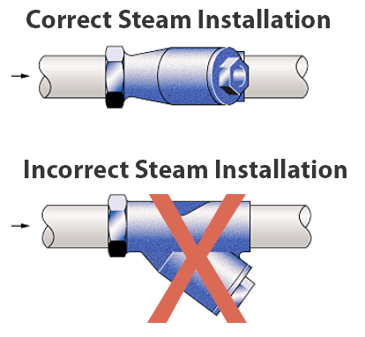 | □ | □
Is there a full-size drip leg installed at the low point just before steam enters the Thermaflo control valve?  Notes:  A) Do NOT install steam traps that sub-cool condensate if the drip pocket is shorter than 24” long  B) Steam trap must be rated to operate at or above the upstream system safety relief valve set point) SEE BELOW FOR BEST PRACTICES  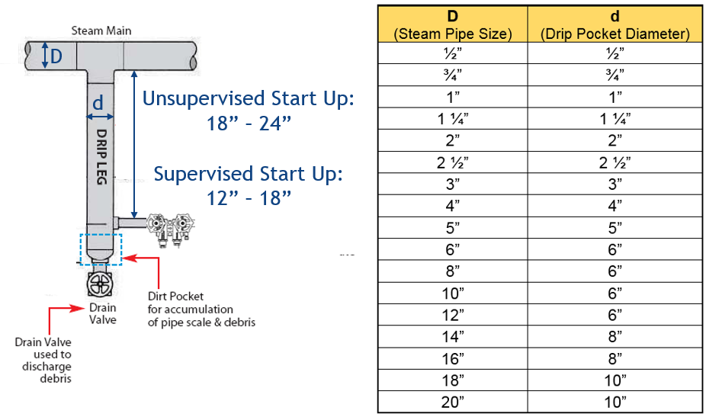 | □ | □
Is the steam piping to the heat exchanger properly sloped in the direction of steam flow? | □ | □
Are proper drip pockets with steam traps installed at elevation changes, and/or for long steam pipe runs leading to the heat exchanger? (Note drip legs with traps stations should be located every 150 FT on long straight runs) SEE ABOVE | □ | □

Check the appropriate box. | YES | NO
If the Thermaflo TH750 or TH500 is supplied with a float & thermostatic steam trap for removing condensate from the shell, is the condensate from the steam trap piped to drain via gravity? Note condensate must NOT be lifted after the steam trap. | □ | □
For Thermaflo TH750 or TH500 supplied with POP steam driven pumps, is the motive steam pressure and total lift and back pressure the same as indicated on the submittals? | □ | □
Is the control panel wired with the correct phase and voltage electrical source as indicated on the submittal?  Notes:  A) Thermaflo recommends each heater control panel be wired through a separate switch between the power source and heater control panel so it can be safely de-energized for service.  B) 120V, 15 AMP circuit recommended.  C) Follow all local building and electrical codes for all electrical connections. | □ | □
For units supplied with PNEUMATICALLY ACTUATED control valves:  Is compressed air connected to the actuator? Check for air leaks and repair prior to site visit. | □ | □
Is the compressed air dry, and free of water and grease? | □ | □
Have all piping connections been test for leaks, and all leaks remediated? | □ | □
Have all heat exchanger bolt torques been checked, and corrected if out of specification? | □ | □
Is the over temperature solenoid valve piped to an open drain and piped in compliance with local codes? (Not applicable for VacuFlo units) | □ | □
Is the hydronic side Pressure & Temperature Relief valve piped separately to an open drain and in compliance with local codes? | □ | □
Can the water using equipment be put in operation so that each Thermaflo TH750 or TH700 can be put under enough load for proper start-up & commissioning? | □ | □

Any items checked “NO” must be corrected prior to scheduling start-up & commissioning to avoid additional site visit costs or potentially voiding the warranty.

